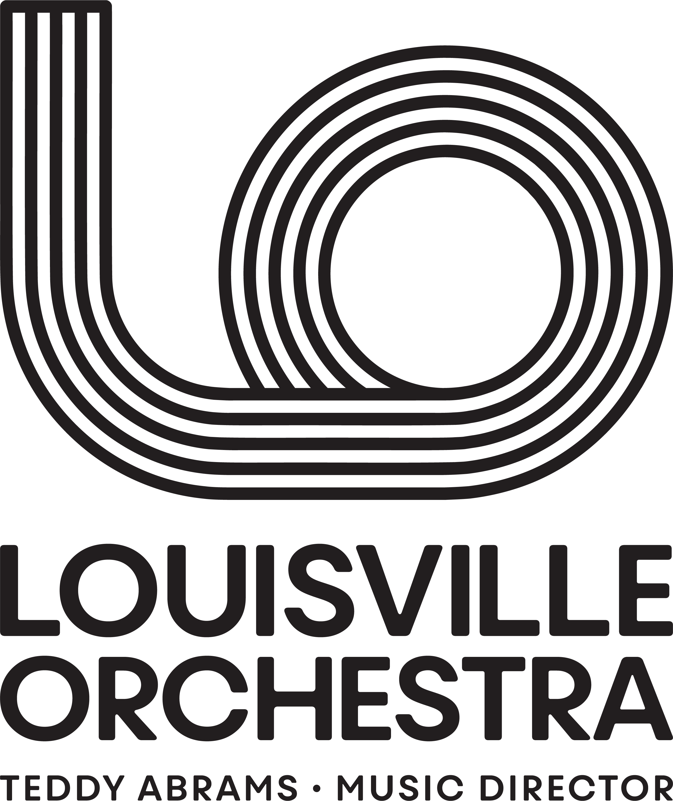
Organization: Louisville Orchestra

Job Title: Marketing Manager

Reports to: Director of Marketing

FLSA: Full-time, Exempt

BACKGROUND TO THE LO
The Louisville Orchestra has long had a strong reputation for innovation, creativity, and excellence. With an annual operating budget of $13M, 61 full-time musicians, 35 full-time staff, a Board of 40 Louisville Leaders, and a 34-week performance season, it is currently an organization that is changing the very idea of what a 21st-century orchestra can be and do. Under the leadership of Music Director Teddy Abrams, the Louisville Orchestra is well on its way toward achieving its goal of being “the most interesting orchestra on the planet.”
https://vimeo.com/743736311/2791647250
Job Summary
The Marketing Manager is responsible for developing and executing revenue-focused marketing plans under the strategic direction of the Director of Marketing. This role is dedicated to maximizing ticket sales, achieving revenue targets, and driving audience growth for individual concerts and single events. Key responsibilities include media buying, operational setup, and promotional coordination to ensure each event reaches its full potential. As a critical driver of the Louisville Orchestra's success, the Marketing Manager crafts and implements a comprehensive marketing strategy for the concert season, balancing the orchestra’s legacy with innovative approaches to engage new audiences and meet aggressive sales goals.
The Ideal Candidate
The ideal Marketing Manager is a results-driven professional with a proven track record in event or concert promotion and a deep passion for delivering revenue growth. They combine creative storytelling with analytical acumen, ensuring marketing efforts are both compelling and effective in meeting sales and audience targets. Adept at collaboration, they work seamlessly across departments, especially with the Audience Engagement Manager, to integrate sales initiatives with broader audience development strategies. This individual thrives in a dynamic, fast-paced environment and is motivated by achieving measurable results. Join our team and take a leading role in driving revenue, increasing attendance, and creating unforgettable live music experiences.
Main Areas of Ownership
- Create and execute marketing plans tailored to each concert, emphasizing unique selling points to maximize ticket sales.
- Strategize pricing, promotions, and sales tactics to achieve revenue goals
- Lead digital marketing efforts, including ad campaigns, email marketing, SEO, and website updates, to drive and sales.
- Provide detailed reports on campaign performance, ticket sales, and audience trends for future planning.

Duties and Responsibilities:

- Develop and implement individualized marketing plans for each concert. This includes understanding the unique selling points of each concert, the target audience, and the best channels to reach and persuade them.
- Design and execute marketing campaigns tailored for individual concerts, prioritizing efforts to maximize single event ticket sales. Directly responsible for online ticketing strategies. Analyze sales data, concert attendance, and other relevant metrics to inform sales. Work with patron services to strategize pricing, seating categories, promotions, and special offers.
- Collaborate with the programming and artistic departments to gain insights into the unique selling points of each concert, ensuring promotions effectively highlight these aspects.
- Allocate and monitor the marketing budget, ensuring optimal spend across various channels to maximize ROI.
- Oversee all digital marketing initiatives, including Meta & Google advertising campaigns and email marketing strategies, and SEO efforts.
- Design and execute email campaigns that promote upcoming concerts, special offers, and other events. Monitor open rates, click-through rates, and conversion rates to refine content and targeting.
- Collaborate with the Audience Engagement Manager to ensure cohesion between engagement initiatives and promotional efforts, especially on digital platforms.
- Regularly assess and report on the effectiveness of marketing campaigns using KPIs, providing insights and recommendations for future promotions.
- Work with the Audience Engagement & Loyalty Manager to gain insights from engagement data, refining marketing strategies to better resonate with the target audience.
- Build and maintain relationships with media outlets, influencers, and potential partners to boost concert promotions.
- Coordinate press releases, interviews, and media appearances related to upcoming concerts and events.
- Oversee the creation of marketing collateral, including brochures, posters, and digital assets, ensuring they align with the brand and effectively promote concerts.
- Effectively use marketing tools to increase awareness on socials, in emails, on websites and in venue including:
  - Coordinate street team and grassroots marketing efforts with local market contacts
  - Update LO website and Facebook events and maintain quality control
  - Execute fan communication plans to ensure key information reaches guests via email, social, website and app – ongoing, announce, presale, on sale
  - Create and manage venue level creative assets for onsite & digital needs
  - Coordinate approvals and execution of promotional sweepstakes
  - Coordinate onsite activations to help drive name acquisition for future show marketing needs as well as coordinate onsite coverage for day of show marketing needs supporting radio partners, meet and greets, press photographers
- Work with internal stakeholders to provide post show marketing analytics recaps.
- Prepares and maintains detailed expense reports for all marketing expenditures, ensuring accuracy, proper documentation, and alignment with budget allocations.

Other duties as assigned by the Director of Marketing

Education:
Bachelor’s Degree in Marketing, Communications, or similar fields required

Qualifications:
- Bachelor’s degree in Marketing, Business, Communications, Arts Management, or a related field. A Master’s degree would be a plus.
- Minimum of 3 years of experience in event or concert promotion, demonstrating a track record of successful marketing campaigns that drove ticket sales.
- Proven experience in managing digital marketing initiatives, including paid advertising, email marketing, and SEO.
- Demonstrated capability in managing substantial marketing budgets efficiently, with a focus on optimizing ROI.
- Experience in media relations, including fostering relationships with media outlets, managing press releases, and coordinating media appearances.
- Experience in leading and collaborating with cross-functional teams to drive cohesive marketing.
- Ability to work day, evening and weekend hours, based on the needs of daily business operations
- Ability to work in a very busy, high-pressure, collaborative, team setting
- Ability to troubleshoot and problem solve independently
- Excellent communication skills, both verbal and written
- Strong organizational skills and attention to detail
- Strong Microsoft Office Suite, G-Suite skills, Good working knowledge of Adobe Creative Suite, and multimedia management software
- Knowledge of Classical music and the other genres of music played by the LO is preferred.

To Apply:
Please send Resume and Cover Letter to:

Mallory Kramer, Director of Marketing
mkramer@louisvilleorchestra.org

